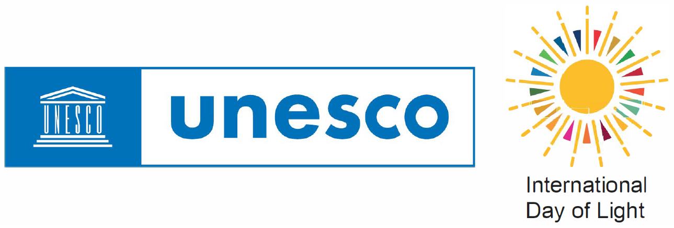 | International Day of Light 2024 Event Registration Form
Instructions. Thank you very much for organising an event supporting the International Day of Light (IDL); this form will allow you to register it in the official International Day of Light calendar. To help us process your information as quickly as possible, please note the following.
1. All events must respect the goals of the International Day of Light in promoting science, education, art, culture, etc. related to the broad themes of light and light-based technologies. All events should also respect the aims of UNESCO in contributing to building peace and promoting sustainable development.
2. Events do not need to take place on May 16 itself. Although many events are organised on or around May 16, we accept registrations for events all year as long as they align with the IDL goals.
3. Event submissions should be in English or French (official UNESCO languages). We cannot guarantee to publish submissions in other languages. We may edit some content if needed.
4. In general, if you are organising distinct events in different locations, please fill in a separate registration for each event. However, suppose you are coordinating a number of different events under a common banner. In that case, you need to fill in only one form, but please indicate the number of events in the last question of the form and list the different locations in the City/Cities textbox itself.
5. Registrations will not appear on the global IDL event calendar immediately, as all new registrations are reviewed by the Secretariat. We review new submissions regularly and aim to place events online quickly. For changes to events already included in the calendar please get in touch with contact@lightday.org.
6. For convenience, we have pre-filled the required fields below with details of an event at UNESCO HQ in 2024. The easiest way for you to complete this form is to type over this information. Do not worry too much about formatting as we will be transferring your event details to an online platform.

Title of the Event: The International Day of Light at UNESCO Headquarters
Country: France [enter “Global” for a worldwide event]
City/Cities: Paris
Description (300 characters): The International Day of Light on May 16 celebrates the role of light in science, art, and culture. It raises awareness about optical technologies and their impact on sustainable development. It is coordinated by the Science Sector at UNESCO Headquarters in Paris, France.
Start Date (DD/MM/YYYY): 16/05/2024
End Date (DD/MM/YYYY): 16/05/2024
Website: www.lightday.org
Institute of Organisers: IDL Secretariat
Contact Name: John Dudley
Contact Email: contact@lightday.org
Category (Highlight): [Conference] [Exhibition] [Festival] [School Activity] [Citizen Science] [Open Days] [Online Event] [Art-Music-Light Show] [Lecture] [Workshop/Seminar] [Competition]
Expected Total Number
of Participants: 200 [Enter only numerals]
Number of events/activities
under a common banner. N/A [If events are held in different locations, list the different cities
in the City/Cities field above.]

Please send the completed form to contact@lightday.org with the subject ‘IDL 2024 Event Registration’.

